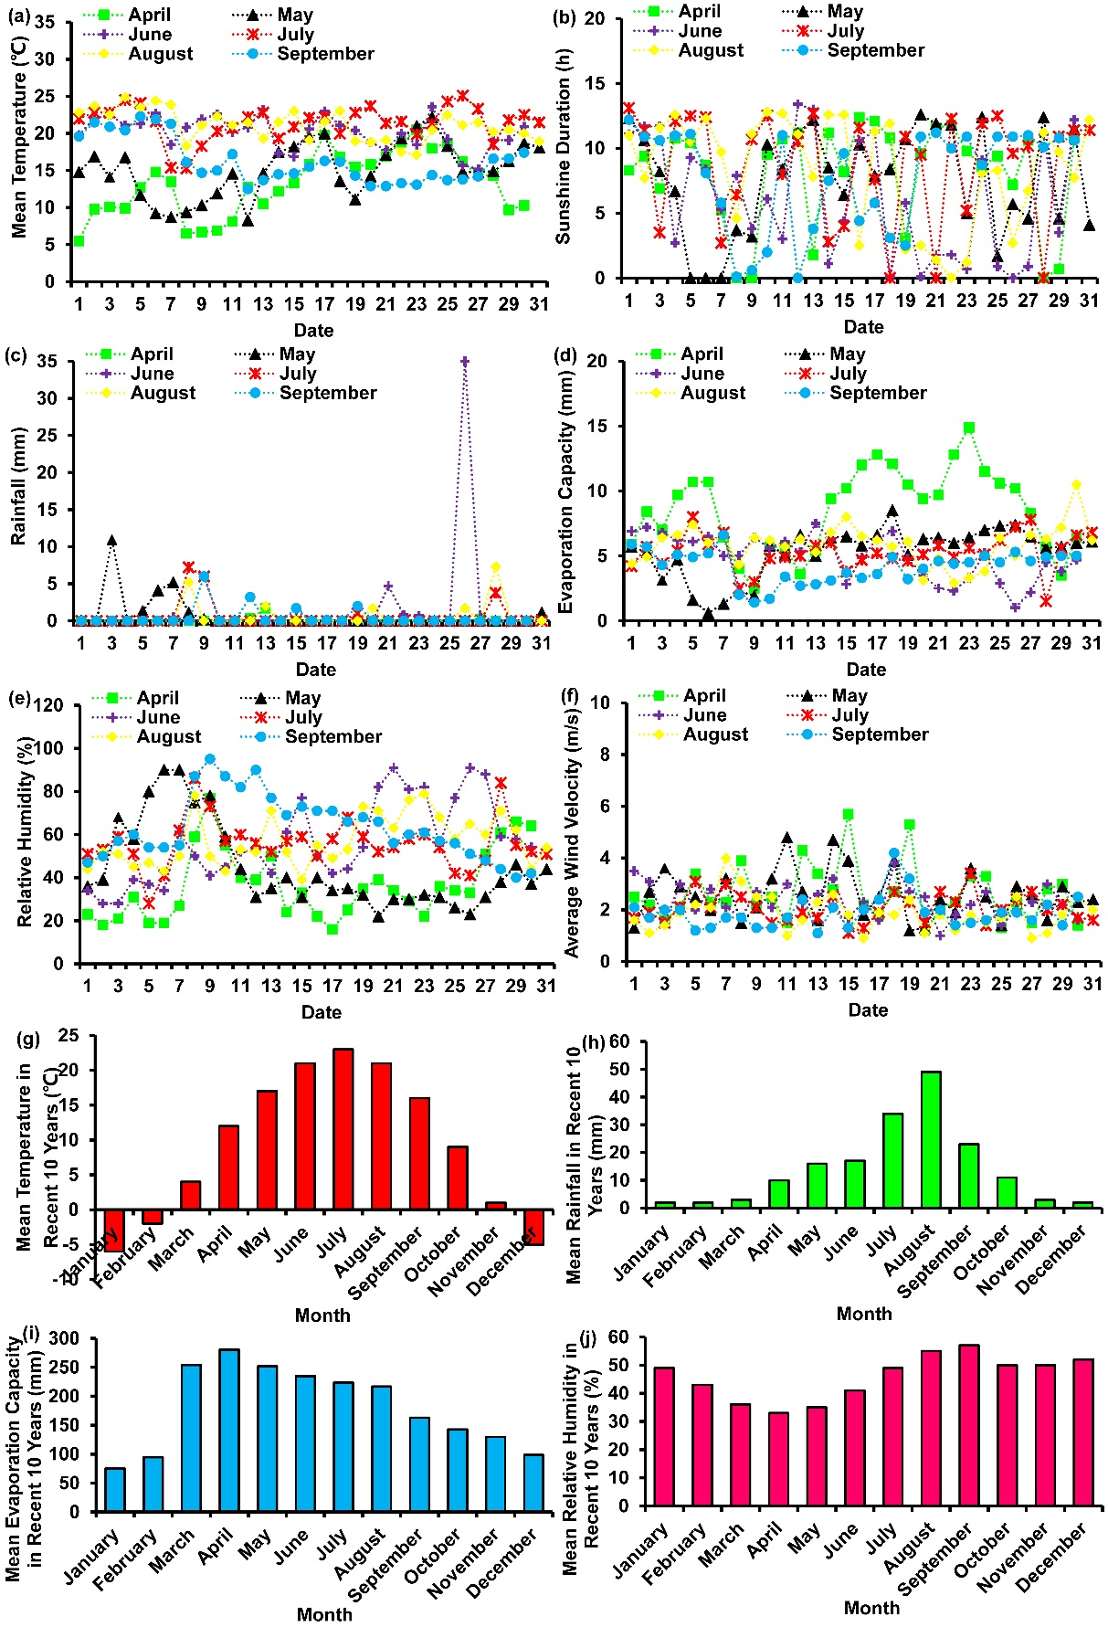
Additional file 1: Fig. S1 Statistics of the mean temperature (a), sun shine duration (b), rainfall (c), evaporation capacity (d), relative humidity (e), and average wind velocity (f) at the experimental site during the growing seasons (from April to September) in 2019, respectively, and statistics of the mean temperature (g), mean rainfall (h), mean evaporation capacity (i), and mean relative humidity (j) at the experimental site in recent 10 years (2009~2018), respectively

